Name: Samra Ahmed

Course: Python Programming

Project: Random Password Generator

**DOCUMENTATION**:

**Overview of the project:**

The project is about random password generator is a python script designed to generate secure and random password for various purpose like registration, password resets and enhance digital security for users by using random and string modules and also list . This script offers to customize options and output for users.

**Question**:

How can we develop a python script to generate random and secure password by using random and string modules with length, uppercase, lowercase digits and symbols?

**Explanation of code logic and design:**

For making this code we utilize the following codes and design to generate the password like import modules in this we use string and random modules to make the password. In this method we define some parameters such as password length and characters by which password will be generated.

**Screenshot with explanation:**

Once, password generation process is completed that is beneficial for user’s purpose. This flexibility allows users to generate secure password and offers reliable and efficient solution to generate random password. In this we use necessary modules and list to generate password.

**Any additional information:**

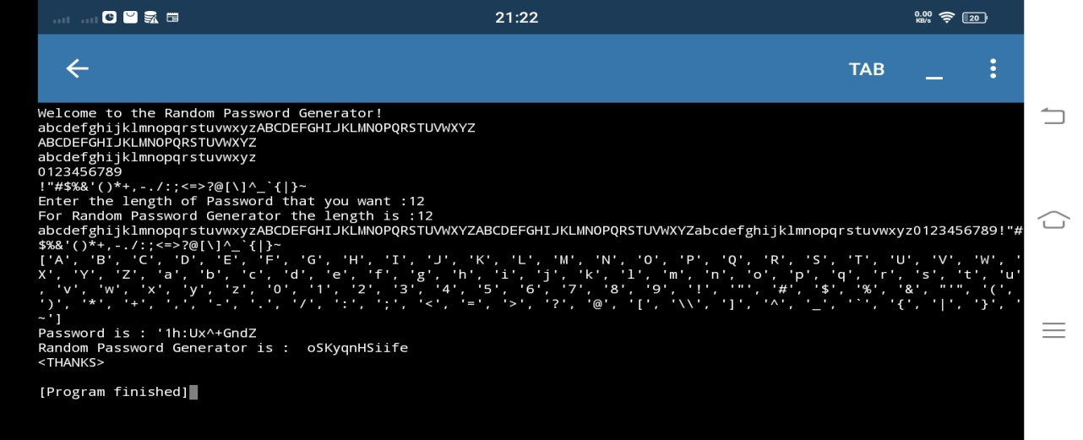In the python we can easily generate random password generator by using different modules then it gives output for the users that he wants.

